Get me IP address of particular domain (guvi.in) How do I find my CPU/memory usage of my server? Test the connectivity between 2 nodes? I have deployed an application in guvi.com:9000, and logs shows my app is running, but I’m unable to view the page. Check whether my port is open or not?

Solution:-

IP address of guvi.in 🡪 using **nslookup** command

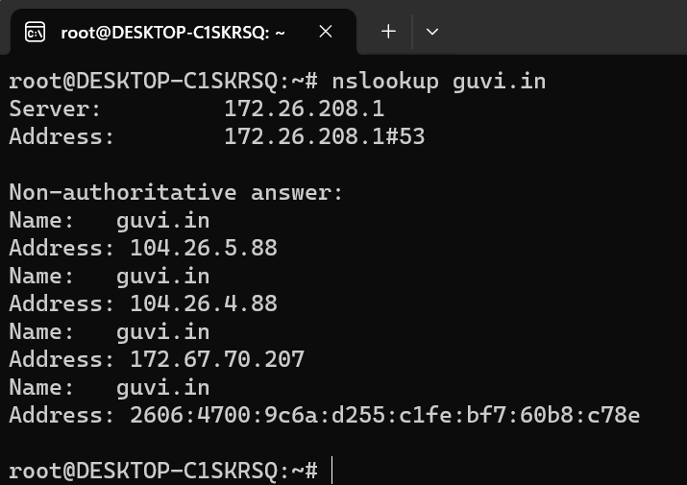

My CPU/memory usage of my server 🡪 using **top** command or **htop** command

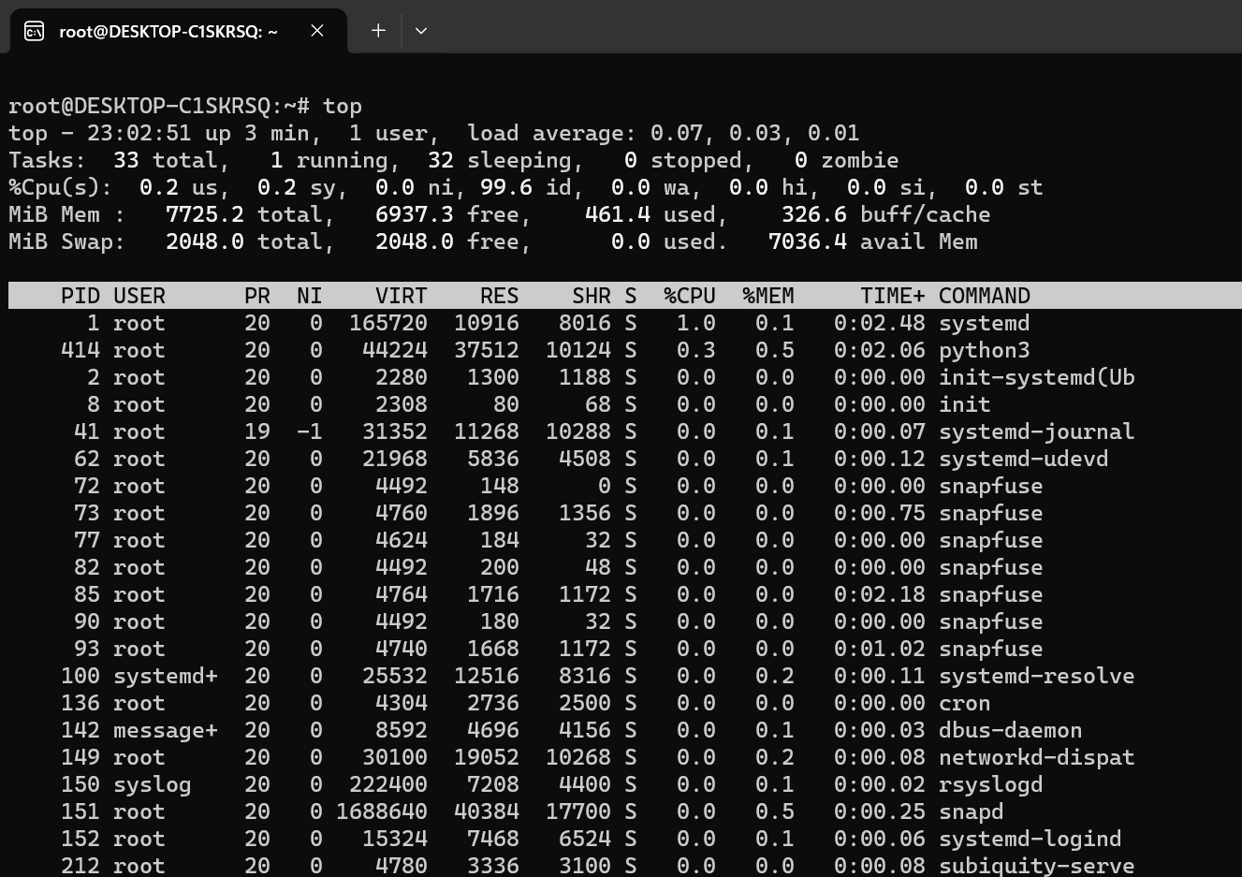

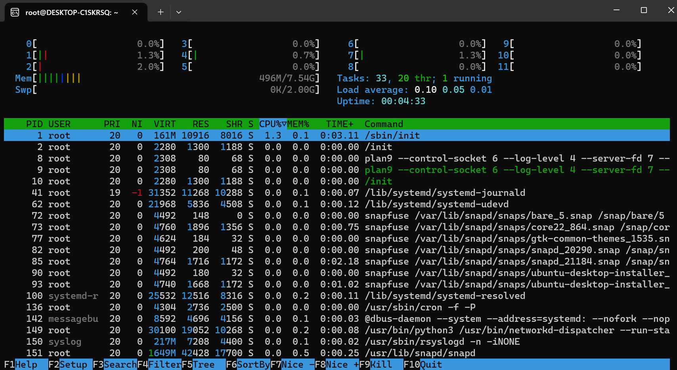

Test the connectivity between 2 nodes 🡪 using **ping** command

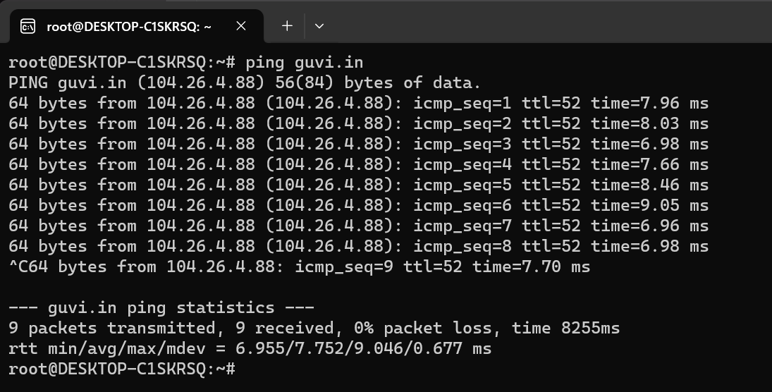

My port is open 🡪 using **telnet** command

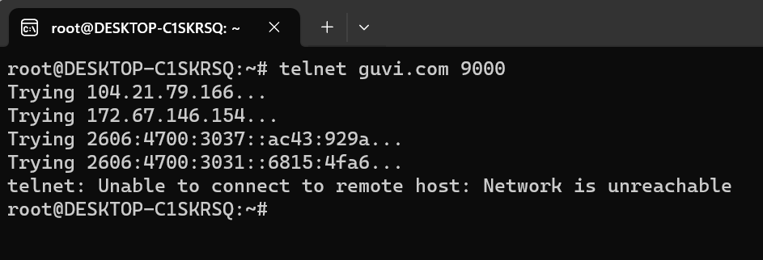

Port is not available.